Please follow these steps to set up your online account, this will give you access in the future to:
- View and request to change class times
- View students swim progression
- Receive digital certificates
- Ability to make overdue payments online
Should this be removed as it is not yet available?
Step 1- Visit: https://envibe.hume.vic.gov.au/
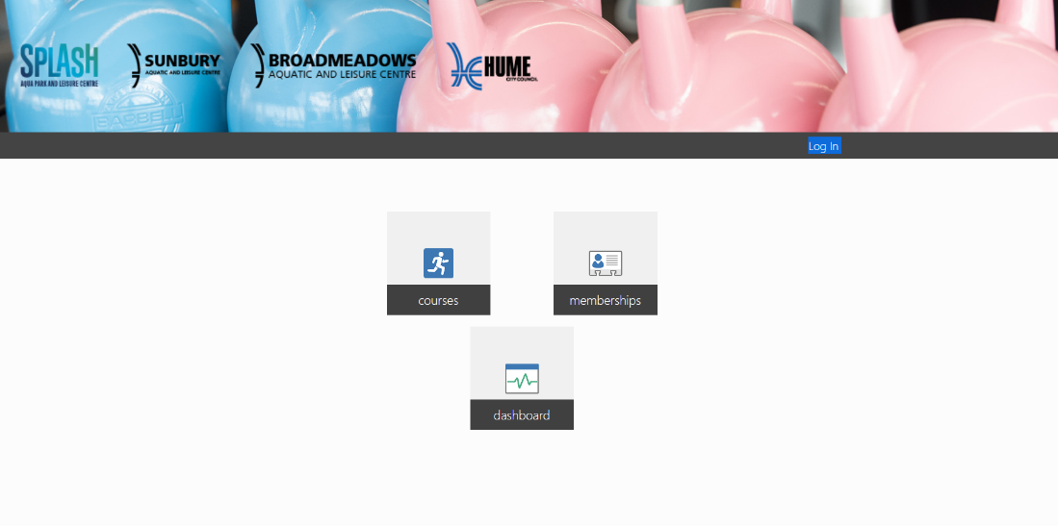
Step 2- Create an account by clicking on LOG IN

Step 3- Select CREATE ACCOUNT
Enter parent/guardian date of birth and email address you originally signed up with
*If you’re unsure which email account is on our data base, please contact your swim school before attempting to sign up
Broadmeadows Swim School- broadmeadowsswimschool@hume.vic.gov.au
Splash Swim School- splashswimschool@hume.vic.gov.au
Sunbury Swim School- sunburyswimschool@hume.vic.gov.au
Once details are entered this will generate an email to be sent to the address input. Follow the instructions on that email, this will involve setting a password that you will use to gain ongoing access to the portal.
Nb. If your do not receive this email, please contact our customer service teams and they will arrange for it to be resent or someone to assist you with a password.
Step 4- Accessing the portal
Once you have created an account, the below page will open with the options you can access through the portal.
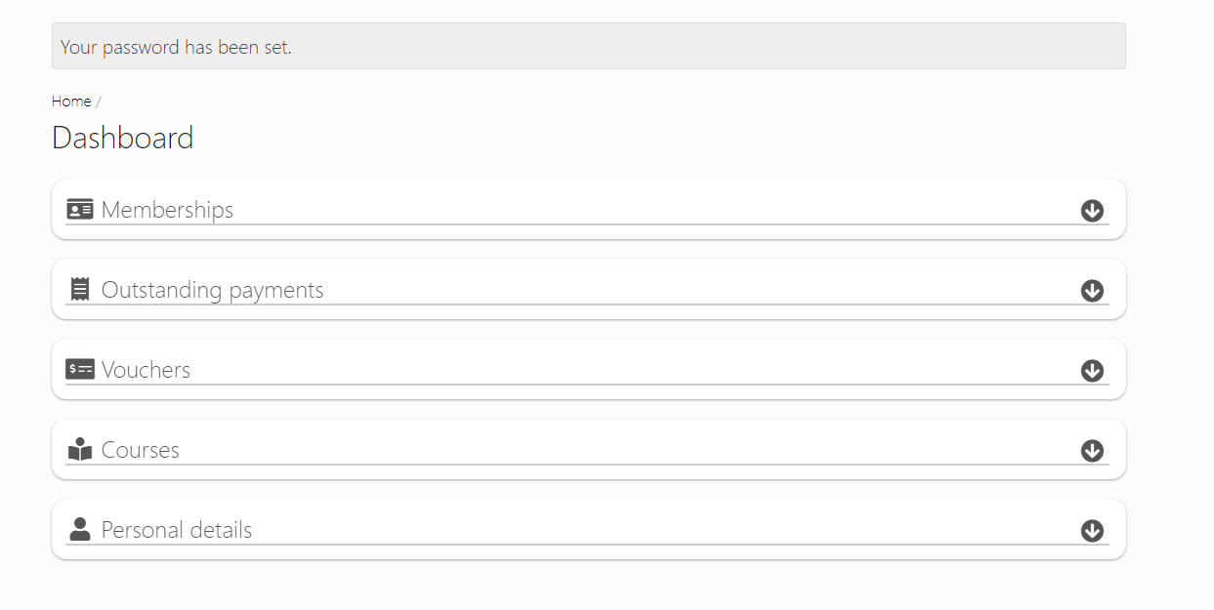
Memberships = Gym/Fitness Memberships
Courses = Swim School Memberships
Step 5- From this screen select HOME, top left-hand corner
Step 6- Select COURSES, this will show you all family members linked to your profile.
From here you can select which family members class details you would like to view, this will show all classes they are enrolled in, their progress through their current level and allow you to change your class time.
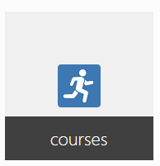

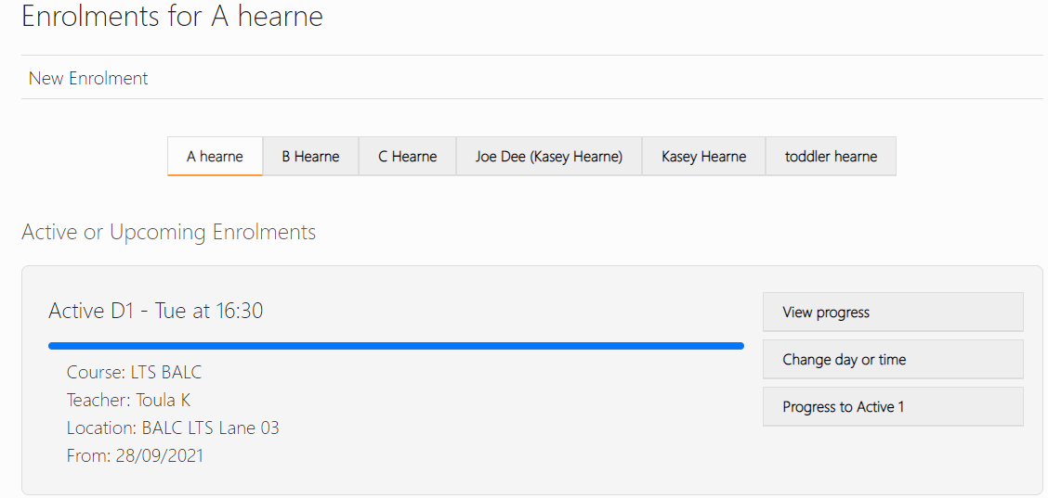

Step 7- To enrol in the Summer intensive program go to New Enrolment and select your applicable Site.
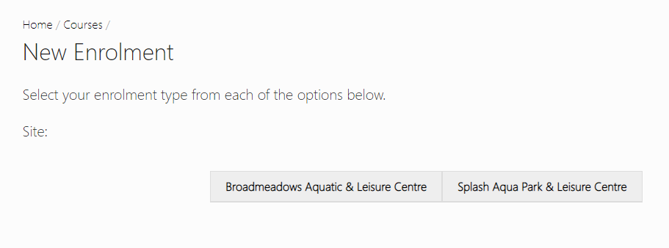
Step 8- Select your week. You can only make one enrolment at a time
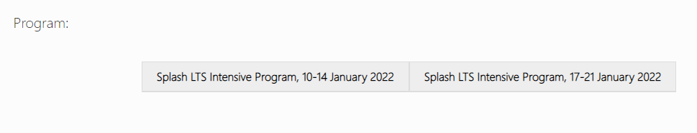
Step 9- Select students’ current level as indicated in your email
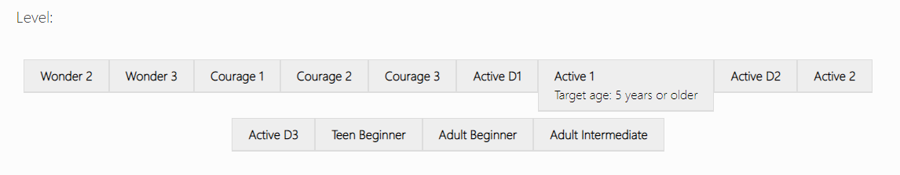

Step 10- Select Monday as Day of the week (program starts on the Monday). Then choose your preferred lesson time.
If we don’t have a lesson that is suitable or you are unable to enrol siblings close together please contact your swim school as we may be able to assist.

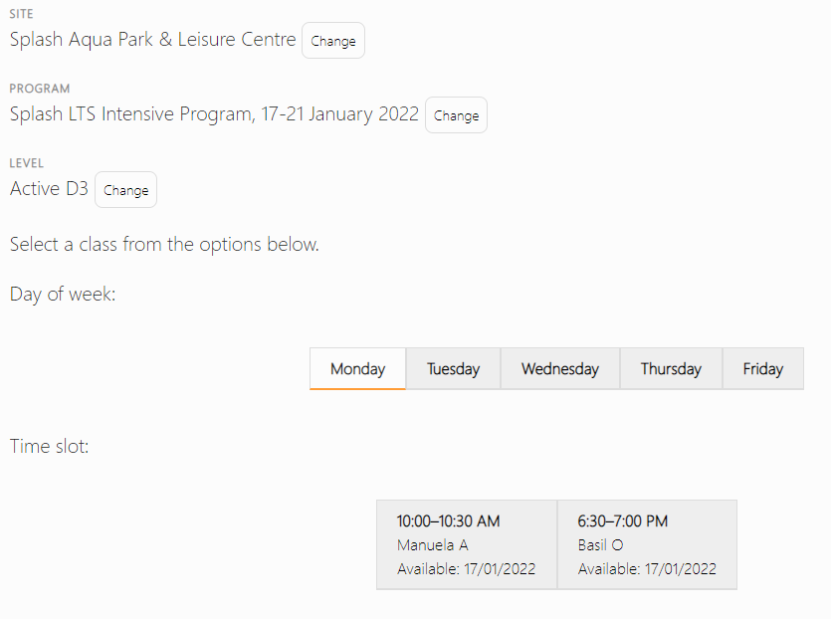
Step 11- You will need to click the start date, ie Monday 17 January 2022 to continue
Step 11- You can now CONTINUE to complete enrolment
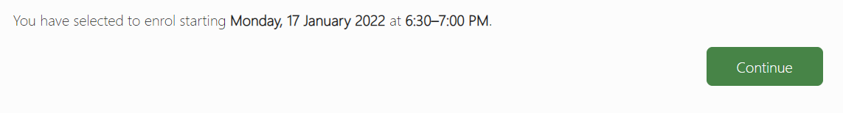
Step 12- Select who the enrolment is for from the linked contacts. Agree to the terms and conditions which are also available on our website and CONTINUE.
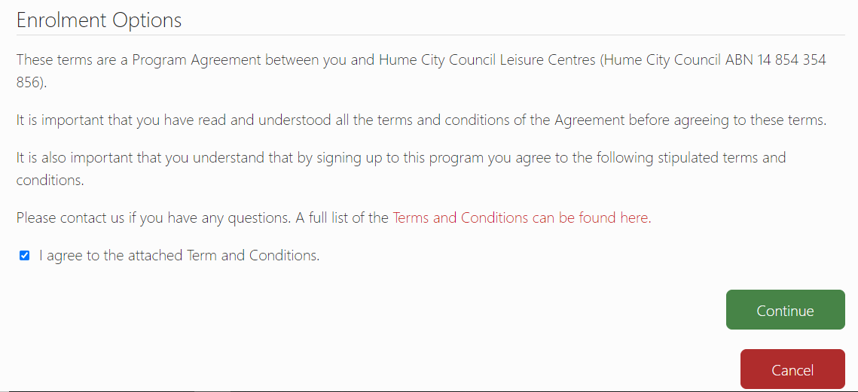
Step 13- From here you will be taken to your cart for payment. We are only able to take one enrolment at a time in the cart.

Congratulations you have successfully enrolled in our Summer intensive program. An email confirmation will be sent to you. If you do not receive your confirmation please contact your swim school team.
Further functionality in the online portal will be rolled out in 2022, including changing class times, changing details and paying outstanding balances.

